--> How to practice legally:

You can learn and practice SQL injection prevention on safe environments like:

OWASP Juice Shop

Damn Vulnerable Web Application (DVWA)

bWAPP

-->download dvwa

You don’t actually install DVWA like a normal program — instead, you host it on a web server (Apache or Nginx with PHP + MySQL).

Here’s what to do step by step:

1. Requirements

Make sure you already have:

XAMPP / WAMP (Windows) or LAMP stack (Linux) installed

(this gives you Apache, PHP, and MySQL/MariaDB).

PHP version 7.x or 8.x (DVWA supports both).

MySQL running.

2. Place DVWA folder

Copy the whole dvwa folder (the one in your screenshot) into your web root:

Windows XAMPP: C:\xampp\htdocs\

Windows WAMP: C:\wamp\www\

Linux Apache: /var/www/html/

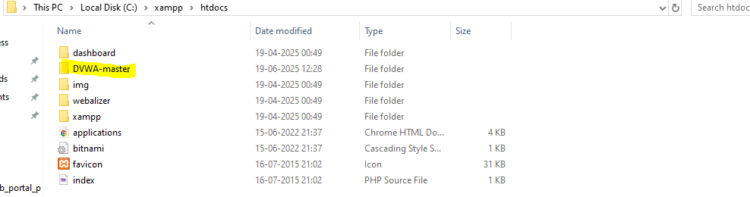

So you’ll have:

C:\xampp\htdocs\dvwa\

index.php

setup.php

config.inc.php (inside config folder after editing)

3. Configure DVWA

Inside the config folder, copy config.inc.php.dist and rename it to:

config.inc.php

Open it in a text editor and edit the database settings:

$_DVWA = array();

$_DVWA['db_server'] = '127.0.0.1';

$_DVWA['db_database'] = 'dvwa';

$_DVWA['db_user'] = 'root';

$_DVWA['db_password'] = 'root' ; // or your MySQL root password

4. Start Services

Start Apache and MySQL from XAMPP/WAMP/LAMP.

--> Key Parts in Your Config

Database settings:

$_DVWA[ 'db_server' ] = '127.0.0.1'; // MySQL host (localhost is fine too)

$_DVWA[ 'db_database' ] = 'dvwa'; // Database name

$_DVWA[ 'db_user' ] = 'dvwa'; // Database username

$_DVWA[ 'db_password' ] = 'p@ssw0rd'; // Database password

$_DVWA[ 'db_port'] = '3306'; // MySQL port

Default security level:

$_DVWA[ 'default_security_level' ] = 'impossible';

⚠️ This means after setup, DVWA starts at “Impossible” level.

For learning, change it to low:

$_DVWA[ 'default_security_level' ] = 'low';

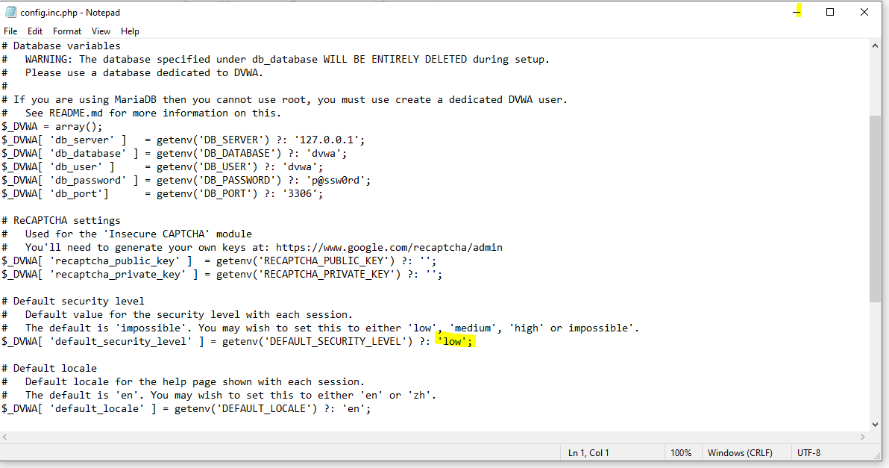

✅ What you need to do now

Create the database & user in MySQL

Open a terminal (or XAMPP shell / phpMyAdmin) and run:

CREATE DATABASE dvwa;

CREATE USER 'dvwa'@'localhost' IDENTIFIED BY 'p@ssw0rd';

GRANT ALL PRIVILEGES ON dvwa.* TO 'dvwa'@'localhost';

FLUSH PRIVILEGES;

output

---------

MariaDB [(none)]> CREATE DATABASE dvwa;

Query OK, 1 row affected (0.001 sec)

MariaDB [(none)]> CREATE USER 'dvwa'@'localhost' IDENTIFIED BY 'p@ssw0rd';

Query OK, 0 rows affected (0.021 sec)

MariaDB [(none)]> GRANT ALL PRIVILEGES ON dvwa.* TO 'dvwa'@'localhost';

Query OK, 0 rows affected (0.001 sec)

MariaDB [(none)]> FLUSH PRIVILEGES;

Query OK, 0 rows affected (0.000 sec)

MariaDB [(none)]> EXIT;

Bye

Perfect 🎉 — you did everything correctly!

Here’s where you stand now:

✅ Database dvwa exists.

✅ User dvwa with password p@ssw0rd exists.

✅ Privileges granted.

✅ Changes applied (FLUSH PRIVILEGES).

-->Start Apache and MySQL from your XAMPP Control Panel.

Open browser and go to:

http://localhost/DVWA-master/dvwa/setup.php

or

http://localhost/DVWA-master/setup.php

check where the php file is

👉 Click Create / Reset Database. You should see a green success message.

Then go to:

http://localhost/dvwa/login.php

--> Use the default DVWA login:

Username: admin

Password: password

--> this error might show up:

DVWA System error - config file not found. Copy config/config.inc.php.dist to config/config.inc.php and configure to your environment.

To solve that:

:

🔹 Step 1: Go to the config folder

Navigate to:

C:\xampp\htdocs\DVWA-master\dvwa\config

Inside, you’ll see:

config.inc.php.dist

🔹 Step 2: Make a copy

Copy config.inc.php.dist

Paste it in the same folder

Rename it to:

config.inc.php

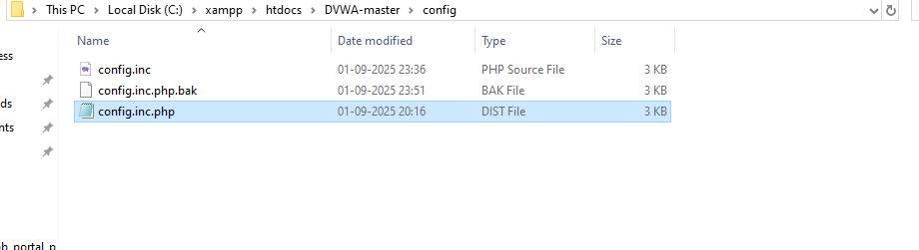

🔹 Step 4: Save and restart Apache

Save the file

Restart Apache and MySQL in XAMPP Control Panel

🔹 Step 5: Run setup

Now go to your browser and open:

http://localhost/DVWA-master/dvwa/setup.php

or

http://localhost/DVWA-master/setup.php

(or sometimes http://localhost/dvwa/setup.php if you put dvwa directly under htdocs).

🔹 Step 6: Create / Reset Database

On the setup page, click “Create / Reset Database”

DVWA will create its tables inside your dvwa database

If everything is correct, you’ll see ✅ green success messages

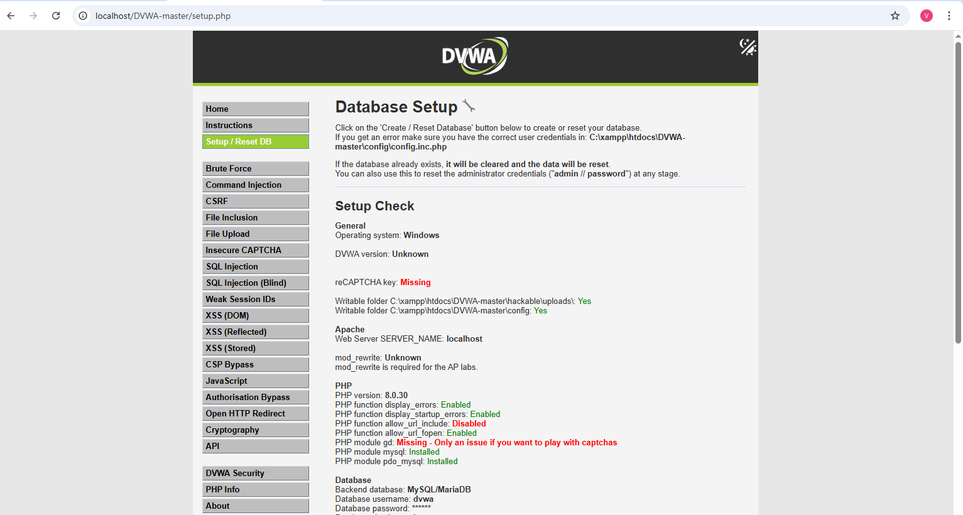

🔹 Step 7: Login to DVWA

Go to:

http://localhost/DVWA-master/dvwa/login.php

Default credentials:

Username: admin

Password: password

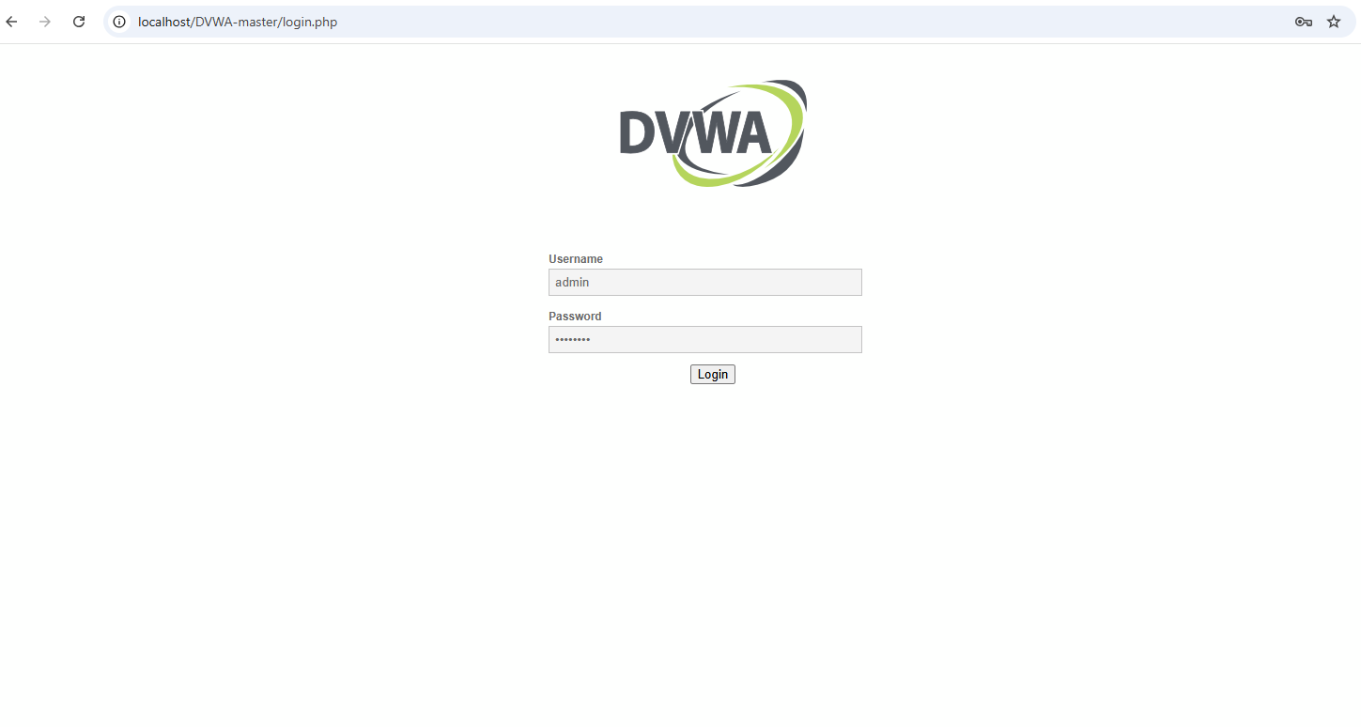

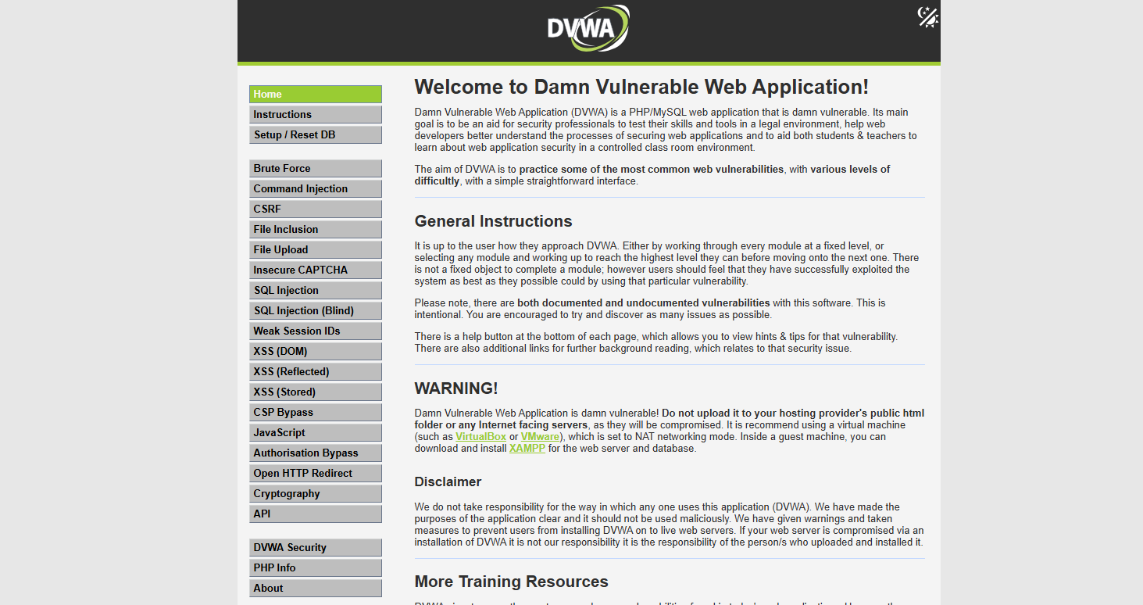

**🔹 Step 8: Set Security Level to Low**

* After login → click **DVWA Security** in the left menu
* Change **Security Level** to **Low** → Submit  
  (this allows simple SQL injection for practice)

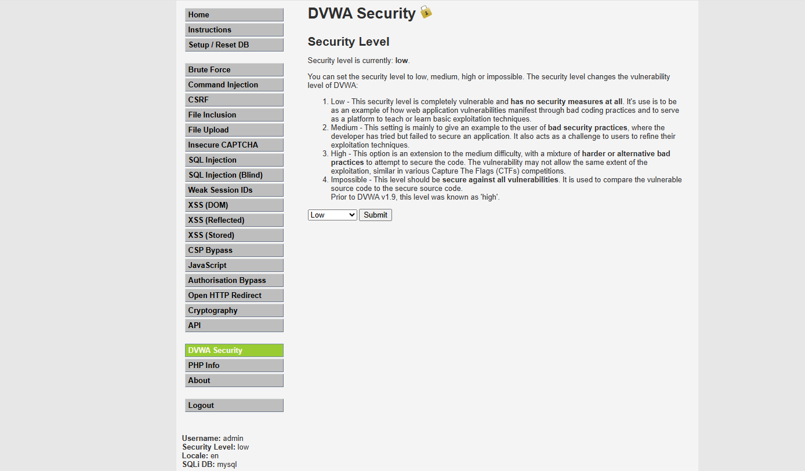

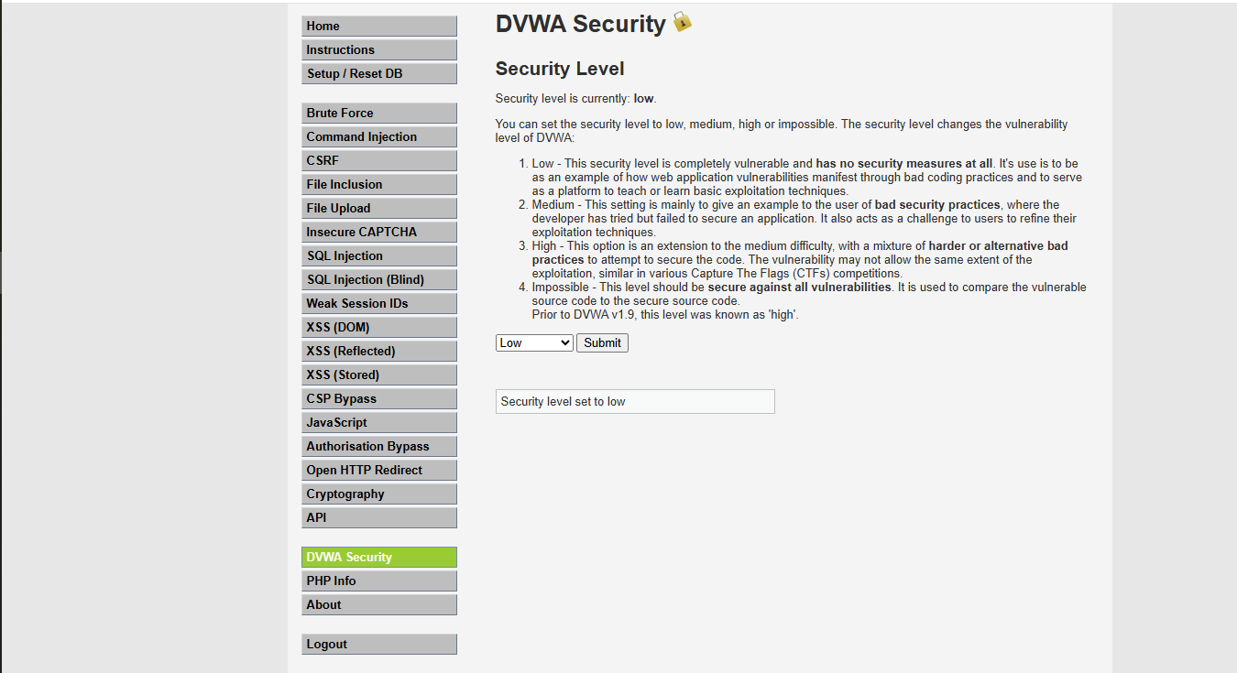

## 🔹 Step 9: Try SQL Injection

* Go to **SQL Injection** in the left menu
* You’ll see a search box asking for a user ID
* Example inputs:
  + 1 → normal result
  + ' OR '1'='1 → SQL injection, should dump all users

